**Step 1:** Download a copy of your region’s shapefile containing the subregional geographic boundaries. For example, a shapefile for the city of Baltimore containing neighborhood boundaries as defined by the US census community statistical areas can be found here: <https://bniajfi.org/mapping-resources/>

**Step 2**: Upload this shapefile into QGIS. In the map uploaded to QGIS, select an individual subregion that you would like to test and save as its own separate layer. For example, in our analysis, this would consist of an individual neighborhood’s boundaries.

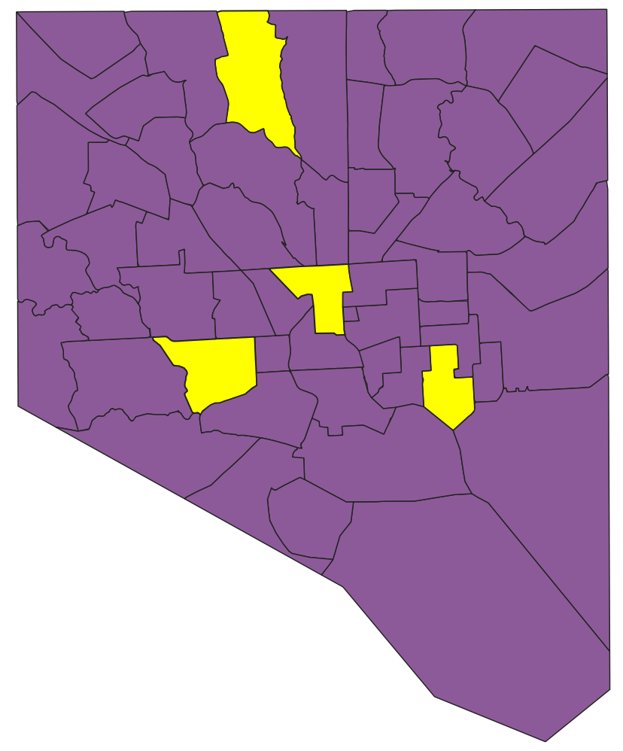

**Step 3:** Then, select only this subregional layer and overlay the street map on this subsection. Follow this video for more specific instructions: <https://www.youtube.com/watch?v=qQyyDxgObd8> . When uploading the street map, select the specific features you would like included. We selected all “highways” that allowed car access and were not motorways or trunk roads as classified here: <https://wiki.openstreetmap.org/wiki/Map_features#Highway>

**Step 4:** Then, use the “create random points” method to place random points on the roads for a neighborhood. These instructions are helpful: <https://mapscaping.com/creating-random-points-in-qgis/> . Specifically, select “random points on lines” and use the layer containing the roads in your subregion. As parameters, specify the minimum distance between points in latitude/longitude degrees. We used 0.000010 as our minimum distance input which corresponds roughly to 1 meter. Then, input the total number of points per line you would like to include. Note that this is not the total number of points you want for your subregion, but the total number of points per road in your subregion. Choose this input so that you have significantly more points than you need per subregion. For example, we chose to list 1,000 points per road.

**Step 5:** Then, take a random sample of the resulting set of points. Use the “random extract” method to select the total number of points that you would like to extract for your subregion. We selected 1000 points per subregion. Save this resulting set of points as a layer. This will result in the following type of image containing the subregion boundary layer, subregion street map layer and selected points layer:

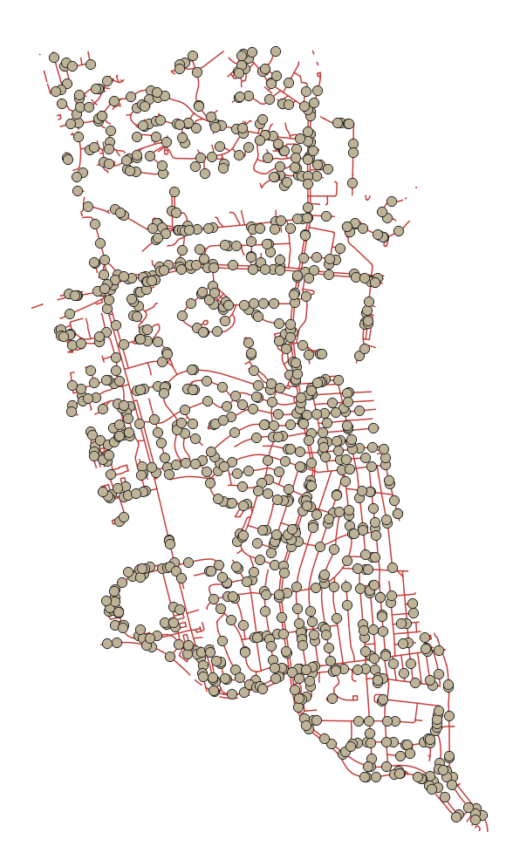

**Step 6:** Lastly, export the points as longitude and latitude coordinates using the Vector Table “Add X/Y fields to layer” method: <https://www.youtube.com/watch?v=s4T1AV0ARFs>